# Exclusive offers to NatWest colleagues Application pack

**To offer a discount to a wide number of companies you can advertise your product (*usually for free*) with the platform provider Next Jump.**

To do this, please ask your helpful contact at NatWest Group to “nominate a merchant” and provide your details.

Link to “[nominate a merchant](https://www.perksatwork.com/nominatemerchant/index/usource/SEARSLT)” for NatWest Group colleagues to fill out on behalf of the retailer.

**To offer a discount on your products to NatWest Group colleagues only,** please see the below application form. Full details on page 2 of this page.



Classification: Confidential

## NatWest Group offers

### Discounts and offers for NatWest Group colleagues

NatWest Group provides its c.40,000 colleagues with access to a wide range of discounts and offers from retailers. Details of these offers are posted on our benefits platform, NatWest Group Offers, free of charge.

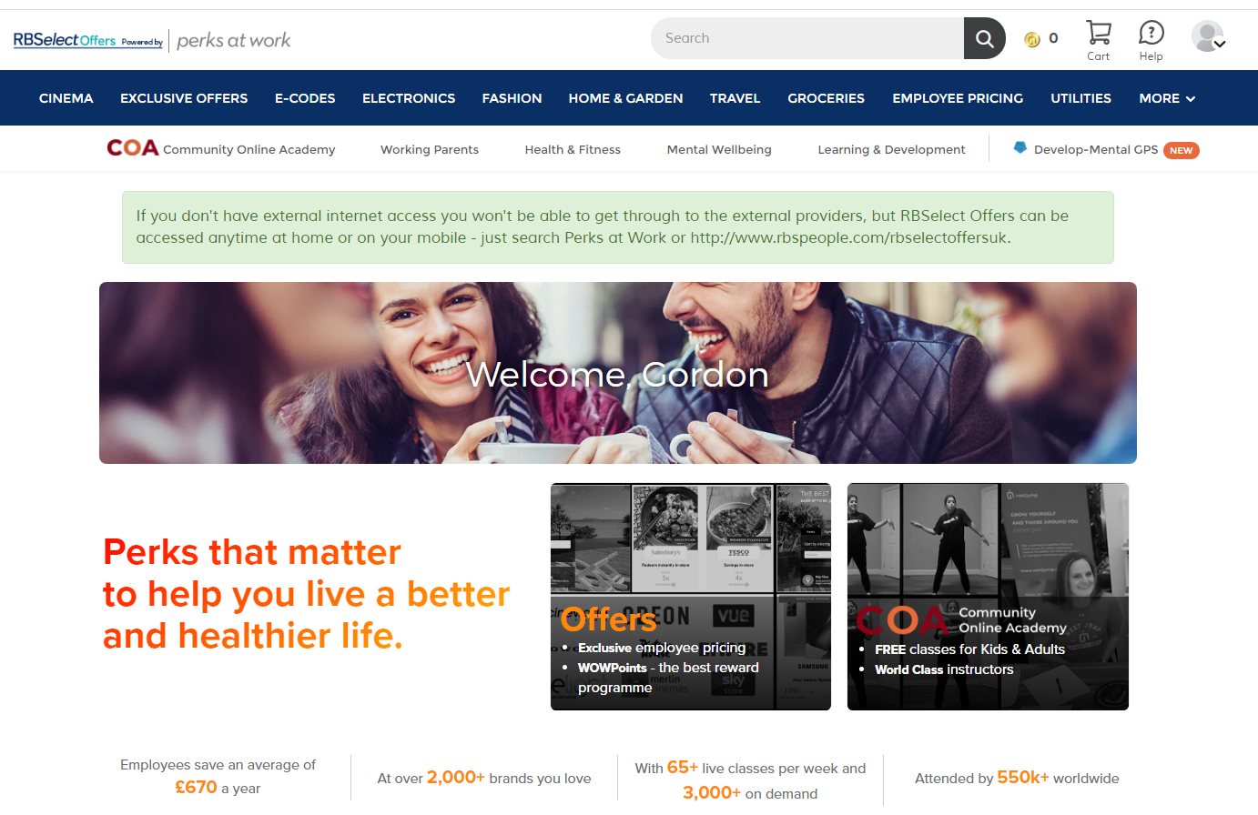

**Our platform hosts offers from a variety of retailers from different industries**

Some retailers offer simple upfront discounts whereas others offer WOWPoints (cashback). For example, the offer from Currys below gives staff up to 20% off the retail price and 7% back as cashback.

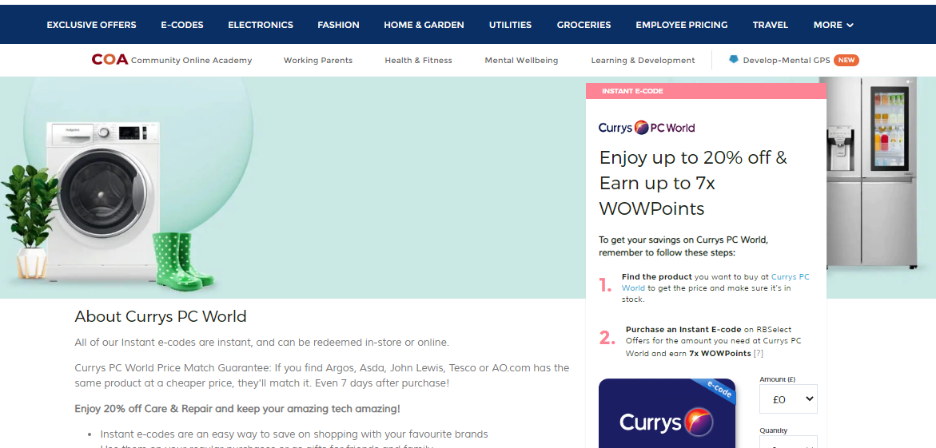

#### 

**As well as hosting offers available to many other organisations, NatWest Group Offers also provides NatWest colleagues with access to exclusive discounts and deals available only to NatWest Group colleagues.**

Below are a couple of examples of the offers made exclusively to NatWest Group colleagues.

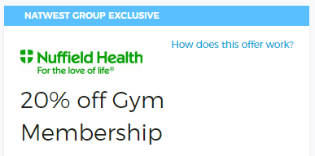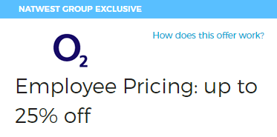

###### If you would be interested in free advertising to 40,000 potential customers, we’d love to give our colleagues access to your products or services. All you need to do is fill out the details of your offer in the application form overleaf.

### Exclusive offers request form

If you would like us to host an offer on our benefits platform please provide the necessary details in the tables below and email the completed form as a word document attachment to [benefits@natwest.com](mailto:benefits@rbs.co.uk) Please note that we cannot accept scanned copies.

#### Offer details

|  |  |
| --- | --- |
| Company name |  |
| Offer Title  This summary of your offer can be a maximum of 50 characters |  |
| Offer Description  You can use this section to give details on your offer or product. You can use a maximum of 2,000 characters. |  |
| Company Image  Insert company image – Max size: 300x300 pixels. Format: Gif, png, jpg, jpeg  This is mandatory |  |
| Offer Restrictions  If applicable |  |
| Location Restrictions  If applicable. If blank the default is UK, NI, Jersey, Guernsey and Isle of Man |  |
| Offer Start Date |  |
| Offer Expiry Date  If no expiry date stated then 12 months from offer start date will be used |  |
| Offer Contact Name  Not published |  |
| Offer Contact email  Not published |  |
| Offer Contact telephone  Not published |  |

### How the offer is redeemed

If the offer is to be redeemed online…

|  |  |
| --- | --- |
| Website address |  |
| Discount Code  If applicable |  |
| Email address  If applicable |  |

…or over the phone…

|  |  |
| --- | --- |
| Contact name |  |
| Telephone Number |  |
| Discount Code  If applicable |  |

…or in store.

|  |  |
| --- | --- |
| Contact name |  |
| Address |  |
| Discount Code/NatWest Group ID Required  If applicable |  |

Please also complete the below declaration

|  |  |
| --- | --- |
| Terms and conditions  NatWest does not recommend, endorse or warrant the quality of any of the products, offers, services or events contained within this site.  NatWest will not provide suppliers with any discounted personal or business banking facilities in exchange for any offer given to NatWest colleagues.  Suppliers/Advertisers are solely responsible for the supply and quality of their products, offers, services or events and will indemnify NatWest against any losses, costs, claims, demands, expenses and liabilities of any nature that arise in connection with products and services offered.  NatWest reserves the right to refuse publishing, terminate offers, or remove or edit content in their sole discretion. If you wish to offer a product or service not exclusive to NatWest please contact [Next Jump (Platform provider for RBSelect Offers).](https://rbs.corporateperks.com/feedback)  By submitting a hyperlink to a website, you agree the link does not contain or portray NatWest. Its affiliates or its staff in a false, misleading, derogatory, or otherwise offensive matter.  Any offer must not be used for illegal or immoral purposes, nor should it breach any statute or common law, any offer deemed unsuitable will be removed without prior warning.  You represent and warrant that you own or otherwise control all of the rights to the content that you submit; that the content is accurate; that use of the content you supply on behalf of the retailer does not violate any policies and will not cause injury to any person or entity; and that you will indemnify NatWest or its affiliates for all claims arising from content you supply. Any content that is challenged, NatWest will release details of you as the contact.  Payment for goods or services purchased will be made directly by the purchaser to the seller. NatWest does not guarantee payment by its employees or pensioners.  You may not use any logo or other proprietary graphic relating to NatWest or its affiliates.  At no time will you trade, sell, or distribute organisation specific or personal information, relating to our employees or pensioners of NatWest including email addresses to any other individual, company, vendor or organisation.  All Offers require a minimum 10% Discount or equivalent monetary value not available to the general public.  Offers are also required to be valid for a minimum of a year, if no end date is stated an expiry date of 12 months from offer start date will be applied.  Other information  Colleague owned Holidays Villas or Time shares are not accepted, please use Workplace.  All adverts submitted will published within 10 days from receipt.  If you require any updates or amendments to a submission or wish to withdraw from the NatWest Group Offers scheme before the expiry date published please contact [benefits@rbs.co.uk](mailto:benefits@rbs.co.uk)  The information classification of this document is Confidential | |
| I Agree to Terms and Conditions |  |
| Name |  |
| Date |  |